UI Prompts for Wabbit: Sullivan Real Estate clients PRD
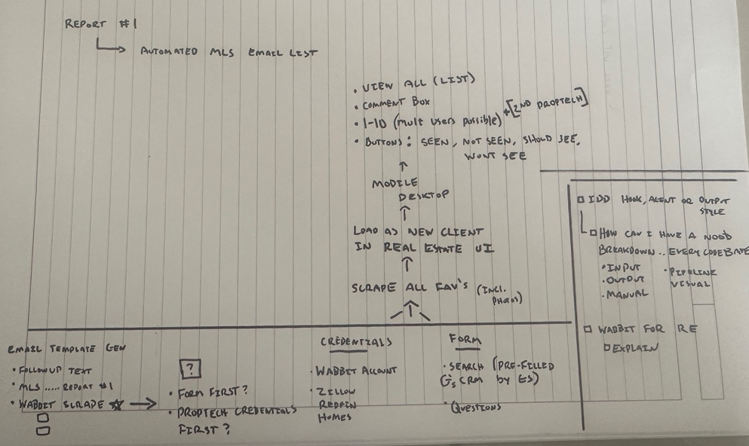

- Email Template Gen HTML
- MCP & context-load
- Credentials
- Form
- Wabbit Launch
- Inputs
- Multi user
- Overall Scope
- Future Outlook
- Workshopping

- Email Template Gen HTML
  - Prompt: Generate a HTML result for email use with a nice film grain background with white Helvetica text of below message, Have a dashboard for inputs and script copy to clipboard.
    - “
Nice chatting other day, [First Name]. I'm on the lookout for you all, based on your criteria.
Below is a download button for properties that could be a match from MLS.
The other button is if you want to dig deeper with AI, you can help me tune your very own AI Agentic researcher with this web app I've built. After creating your account, you’d start with confirming the contents of your criteria form. From here, you can jump straight into the platform to rank what’s on market/Coming soon. However, I recommend not just looking forwards at properties you’re seeing for the first time, the Agentic researcher wants to have context of your ‘Absolute Experiences’ into it’s calculus.
What’s an Absolute Experience? It’s the opinion you’ve already formulated based on the house hunting homework you’ve already done. In-person tours, online research, Open houses, drive-by’s, etc… Simply upload your means of tracking document (.xlsx, .csv) OR sign in to your Zillow, Homes.com, Redfin account (only these supported at the moment). Your feedback for houses you have ‘Starred’ or ‘Added to Favorites’ comes in the Ranking Interface of a 1) 1-10 ranking and 2) a blank text box ready for your Qualitative thoughts on each record/property. BOTTOM LINE, it’s simple, it’s quick and based on my data science skills & real estate industry knowledge applied to the backend, enhanced with AI research, results show that it’s powerful.
[Maybe you and your partner have different opinions, that’s OK! It only better trains the model. Scores are combined for a RAVG- Ranking average & alternate opinions give insights. Quantifying the qualitative, where considerations are weighed in a very detailed manner for everyone to get on the same page.]

Full breakdown is explained in link below. In case of a name misspell, here is a Unique key to search your Form in Wabbit:
[Unique Key]
Besides that, I've made a list based on your criteria so expect emails from the MLS so you can see everything not public facing yet.
Talk soon.
At your convenience,
Garrett Sullivan
(480) 717-2802
gbsullivan@mac.com

Button 1 – MLS COMPS
Button 2 – Wabbit (to Sign Up page)

- MCP & context-load
  - Directory with every cc [copy] in to start
    - copy new instance into current project/codebase
    - .claude created in main
    - extract from every cc [copy] folder and place inside .claude
    - hooks, agents, commands, output-styles, ai-docs Loaded
    - quick test confirm all active…

  - MCP’s configured
    - Load Supabase MCP - can handle signup/sign in
    - Load Cloudflare MCP
    - Load Vercel MCP
    - Ensure in prompt: with proper email confirm authorization for new Create Account users.
    - Context load

  - .README and CLAUDE.md have:

- Credentials
  - Prompt: From the Sign Up page, go through a basic sign up process by entering their [First Name], [Last Name], and [email]. Also two boxes to check for privacy statement and subscribe for Wabbit updates.
- Form
  - Prompt: Search for READ Referenced documents, including: ‘CRM-Buyer-preferences.xlsx’ which contains records of individuals and their preferences they’ve identified & shared with me, as well as ‘MLS scrape_BuyerEmail.xlsx’. Create a Typeform stylized but professional form using UI reference folder ‘ui_refs’ numeric naming of the files inside represent order of UI. READ Referenced documents, including: ‘CRM-Buyer-preferences.xlsx’ which contains records of individuals and their preferences they’ve identified & shared with me. UI order of operations wise, 1) Search feature prompts the client to type their own name and looks from database set to site ‘CRM-Buyer-preferences.xlsx’. ‘Next’ button still clickable if no chosen from Search/dropdown menu. 2) second page loads the pre-loaded or blank Form dependent on their action in step 1. Goes through questions in row 1 of ‘CRM-Buyer-preferences.xlsx’ not one by one or all together but looking at row 2 being the Page Index. If 5 for that column’s question, that would be on the 5th Form loaded page (takes 4 ‘Next’ button clicks; not including the step 1 search feature. Form starts after step 1.)

- Wabbit Launch
  - Prompt: This is a web app with functionality such as it requires sign up/in from user, first popup is a quick tour overlay, after this, pop-up with quick briefing at the top, below header of “Help AI do more For You” that you can cancel out of has buttons to connect with Zillow, Redfin and Homes.com. Once clicked out of or when 1 completed, Wabbit starts you on the 1. Rank Feed has a ranking UI 1-10 for records pulling in from a subsection of a database based on a quick form they completed during sign up. The site saves all records for submissions from the users main view for every record. They also have the ability in settings to see their voting history, to see a list view and upon click of any record, that populates in the main page Rank Feed, and also has ability to invite friends, star for favorite records
  - Menu
    - Rank Feed: Referencing ‘1-rankv2.png’ in /wireframes-ref/. Left side menu has some indication of selected UI modern underline. In the first top left quartile to the right of the menu, is the ‘Property_Info’ tile. Top right tile to the right of ‘Property_Info’ is the ‘Rank_tile’ tile. Bottom left, directly to the right of menu and under ‘Property_Info’ is the ‘Google_Interactive_Map’ tile. To the right of this, under ‘Rank_tile’ is the ‘Property_Image_Carousel’.
      - ‘Property_Info’: The following should pull in from records for each of the following from the list view filtered by high success likelihood determine initial order.
        - [Property Address]
        - [List Price]
        - [Mailing City]
        - [ZIP]
        - [Schools]
        - [HOA?]
        - [Reno Year]
        - [Build Year]
        - [Jurisdiction]

      - ‘Rank_tile’: Text box and slider for each of the following Key Ranks
        - Price:Value
        - Location
        - Layout
        - Turnkey

      - ‘Google_Interactive_Map’: Connect with ‘dev-buildout/js-markerclusterer-main’ to mark the following for each record. These will be found in the database that passes through OpenAI API key
        - Property Address
        - IF in Form: [Commute to Address 1]
        - IF in Form: [Commute to Address 2]
        - IF in Form: [Commute to Address 3]
        - OpenAI call: [Schools]
        - OpenAI call: [Entertainment Districts]
        - OpenAI call: [Groceries]

      - ‘Property_Image_Carousel’: This pulls from the ‘MLS_Image_scrape_[BuyerEmail]’/[PropertyAddress]

    - List View: For user, pulls in their MLS list coming from their pre-filled and confirmed Form upon login, as well as records coming from if they completed their Zillow, Homes.com and Redfin connection. Referencing 2-list-view.png from /wireframes-ref/.

    - More:
      - Reference ‘3-more.png’ from wireframes-ref
        - Light/Dark Mode toggle
        - ‘Font size’ (5-option scale with little ‘a’ to big ‘A’ UI )
        - ‘Invite…’ If select this button, prompted with pop-up open a textbox for entering their phone number or email. If Sign up process through the link/special code goes through, then reference the “Multi-user-re-ui”

    - IF NOT OPTED IN, for connecting with Zillow, Redfin, Homes.com, then at bottom right in Menu bar, have icons for all three.

- Inputs
  - ‘CRM-Buyer-preferences.xlsx’
    - Starting in column K:K, we have questions to be included inside the Form. B:J are all inputs to search for a pre-filled Form with. Also B:J is used for the email.
    - Client recorded information starts in Row 4 and will continue downward. Row 1-3 is just administrative.
    - References:
      - Reference Row 2 labeled Index in A2 for where in the Form what page it should be on.
      - Reference Row 3 for Notes pertaining to what kind of field type for the answer for that columns question.

  - ‘MLS scrape_[BuyerEmail].xlsx’
    - Manual step to be done and saved/uploaded for codebase reference. Once this is successfully linked with the buyer email i.e. they’ve created their account with this email, then all properties will be populating upon Launch Wabbit, populating the List View for the account for ranking.
    - Field matching to Rank Feed ‘Property Info’ that then populates some other tiles

  - /‘MLS_Image_scrape_[BuyerEmail]’/[PropertyAddress]
    - Images in whichever subfolder titled the properties Address within are associated with the buyer and populate in both 1) the List View with the Header Picture and 2) the Rank Feed Property Image Carousel.

  - ‘Interactive_Map_Locations.xlsx’
    - In addition to pulling from the record for Property Address, the Form will pull in their [Commute Address 1] and [Commute Address 2].
    - From a OpenAI call, output to ‘CRM-Buyer-preferences.xlsx’

      - Schools [Using the Property Address, provide a table of top 3 private schools in close proximity and the public school districts required for the different age groups/grade levels, Column A is Private/Public, Column B is GradeAttend, Column C is DistanceFrom, Column D is StudentPopulation]
      - Entertainment Districts [Using the Property Address, provide a table of the nearest shopping area on the scale of Fashion Square Mall, Biltmore Fashion Dist., PV Mall, Desert Ridge, High Street, etc…, Column A as the EntertainmentDistName and Column B as the EntertainmentDistAddress, Column C is DistanceFrom].
      - Groceries [Using the Property Address, provide a table of the 3 nearest grocery stores. One of which must be nearest Costco, one must be nearest Trader Joe’s, table should have Column A as the StoreName and Column B StoreAddress].

- ‘Multi-user-re-ui’
  - Prompt: In the case that a User navigates to More -> Invite and that email invitation is accepted via a created account, there will come a seperate List View where the following differences must be noted.
    - Ranking Average between the 2 shows in the 4 Key Rank options
    - A icon of 2 voted (placeholder at directory: 2voted_placeholder.png) vs just 1 voted icon is in the List view.

- Overall Scope
  - This project will be in Supabase using PostgreSQL, READ and understand the .xlsx and all files mentioned as it is OK to create a transfer plan where everything is mirrored between excel and this backend.
  - For now, have the buttons for Zillow, Redfin and Homes.com have a simple popup for sign in with the logo of each respective centered near the top of pop up with space for text underneath “Share credentials to add your 3rd party favorited property data for integration with Wabbit”
  - Consider but do not limit yourself to tools like the ‘js-markerclusterer-main’ for mapping in Rank Feed. Also Cloudflare. Also Vercel. And a tool for simple simple email sign in and auth for a unique ID contained in that email to be used upon account creation.

- Future Outlook
  - Looking forward to a place we are not at currently but should be noted, there will be NO manual step needed and pulling from SparkAPI key for the MLS, all data thus linking the Form with the download from the MLS, removing the Inputs ‘MLS scrape_[BuyerEmail].xlsx’ and /‘MLS_Image_scrape_[BuyerEmail]’/[PropertyAddress].

- Workshopping

  - Using all credentials in .env.local, let's flush out the backend.

Let’s add a Profile sign in/account icon to the top right of Menu. Set default should be a regular user to a new site, i.e. upon click of Profile icon, Rank Feed, List View, Settings it asks you to sign in. All current functionality of tiles bringing straight to each page with records and John Doe email and functionality should be copied over to ‘Full Demo’ (ONCE IN FULL DEMO; Have ‘Demo’ banner at bottom screen that stays throughout all demo pages, have a hyperlink ‘Click here’ to return to Menu aka non-Demo mode) – Demo Mode auto-signed into Admin account ‘support@wabbit-rank.ai’ (create this in database with the sample records 7525 E Gainey Ranch Rd #145, 3120 N 38th St, 5420 E Lincoln Dr, 9820 N Central Ave and all. Only one Menu, do not copy this into Full Demo, instead just jumping straight into Demo-List View.
The real Menu button for List View, Rank Feed and Settings should contain a popup to sign in IF not signed into account. IF not signed in, clicking on Preferences Form will pop up Please Sign In. Same goes for If not Signed In, Preferences Form, Rank Feed, List View, Settings from the Menu should pop up window of Sign In. IF signed in (non-Demo support@wabbit-rank.ai), ‘Preferences Form Edit’ pulls that account/persons responses and let’s them edit if they want. Same goes for If Signed In, That way sign in to different profiles & access different Rank Feed, List View, *Edit* Preferences Form, Settings.

Let's change the Preferences Form so that if Not signed in, can still access to fill a form/create User record. Also we need to add a next page/step of the Preferences Form a 'Email' question with a single line textbox. Backend should reflect saving this info to the account and sending a verify/setup email functionality to create their account with

